Ideation Phase
Empathize & Discover

Date | 31 Oct 2025
Team ID | NM2025TMID01169
Project Name | LAPTOP REQUEST CATALOG ITEM
Maximum Marks | 4 Marks

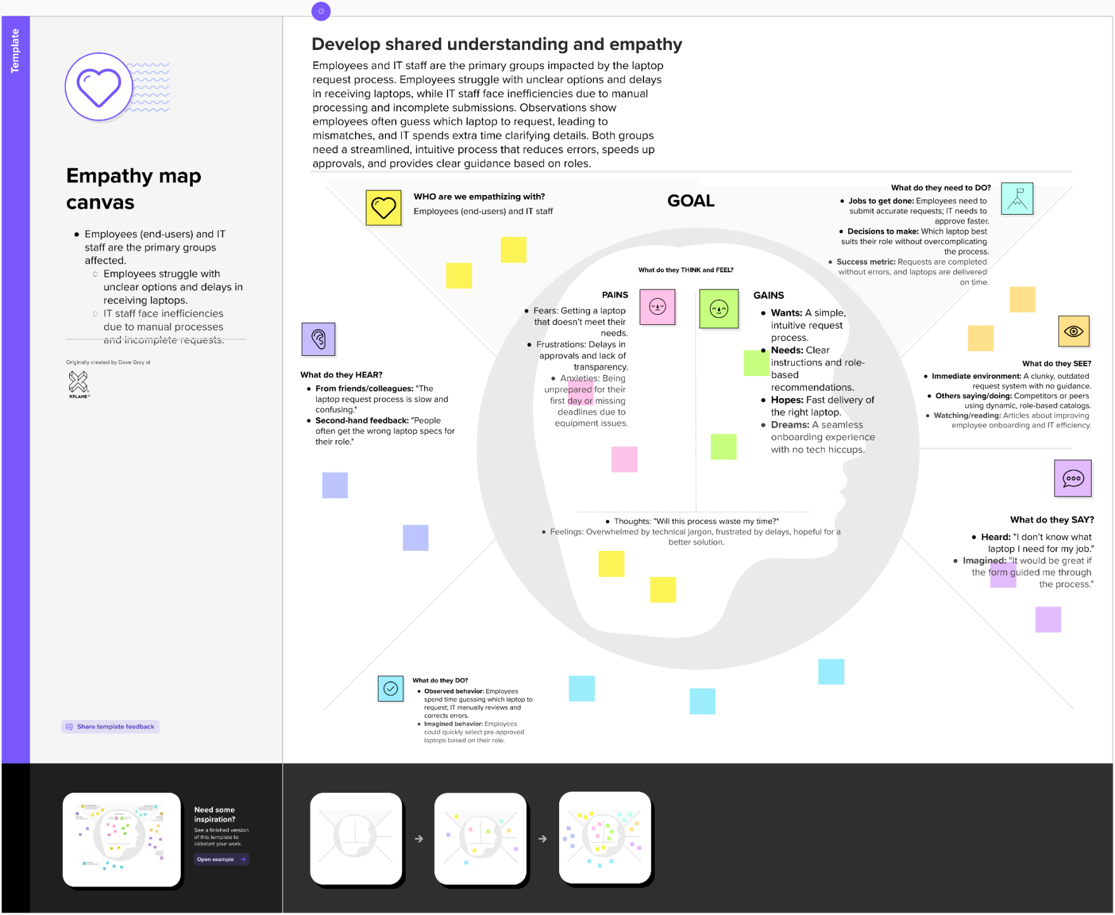
Empathy Map Canvas:

